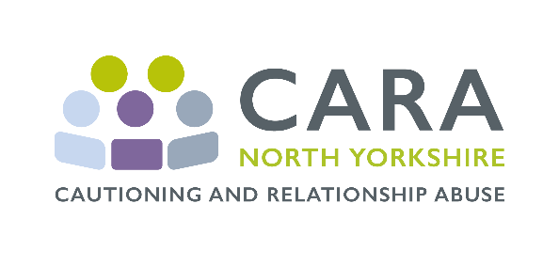

What is CARA?
CARA (Cautioning and Relationship Abuse) is a proven and recognised model of interventions with offenders of domestic abuse who are subject to Conditional Cautions. CARA is evidence based, and has been evaluated by Cambridge University.
C

CARA is an awareness raising intervention - participants engage and reflect on behaviour that is placing their families at risk. The sessions are carefully constructed to enable participants to identify as being abusive and to explore what constitutes healthy, positive relationships. A pair of 1-1 telephone sessions provide participants with strategies and skills to build respectful relationships. This includes focusing on different aspects of violence and control, and on skills for better relationships and parenting.

CARA 1-1 Telephone Sessions
CARA utilises a trauma informed approach and motivational interviewing techniques delivered across the pair of 1-1 telephone sessions. The aims and objectives of the 1-1 telephone sessions are to enable offenders:
- To reflect on the offence including personal triggers
- To gain an understanding of different types of abuse within a family dynamic
- To recognise physical symptoms of anger and the feelings which lead to anger and then violence
- To recognise the damaging effects of behaviour on themselves and others
- To understand personal risk and protective factors
- To reflect on self-esteem and self-regulation designed to increase personal resilience
- To establish personal time out strategies and safe conflict
- To understand communication & conflict resolution skills
- To identify future strategies for sustaining change
- To provide signposts to other relevant agencies/organisations

CARA 1-1 telephone sessions are run in pairs – each offender attends two 1-2 hour sessions 4 weeks apart on a 1-1 basis with a Facilitator. 1-1 telephone sessions are for male and female offenders, and for intimate (partner/ex-partner) and familial domestic abuse.
1-1 telephone sessions can be arranged for a time and date that suit both the offender and Facilitator, to maximise opportunities for those referred who are in work or education to attend, and taking note of the time period of 16 weeks for Conditional Cautions to be completed.

Victim Engagement
Victim engagement and feedback is key to CARA. Between the two 1-1 telephone sessions, the partner/ex-partner or family member of the offender is contacted to seek information on any changes (positive or negative) that they have observed in the offender’s behaviour, and to assess any safeguarding and/or other referral needs. Any relevant feedback is provided to the Facilitators only, prior to the second 1-1 telephone session, so they can address any concerns or issues with the offender.

CARA in North Yorkshire (NY)
York and North Yorkshire Combined Authority (YNYCA) has commissioned lead contractors Restorative Solutions CIC (RS), partnered with The Hampton Trust (HT), to deliver a pilot which will run until September 2027 and will inform future commissioning. This partnership brings substantial relevant expertise and local knowledge to this project.

Eligibility is for standard risk first time offenders, issued with a Conditional Caution by North Yorkshire Police (NYP). All referrals/bookings are made directly by NYP when issuing the Conditional Caution. CARA mobilisation in NY began 1st October 2025 and delivery/referrals will begin in January 2026.

Whilst the initial focus is about engaging and raising awareness with the Police, RS will ensure that key stakeholders are aware of the CARA service and are developing a stakeholder engagement plan to ensure services across NY, including those hard to reach communities, are aware and confident of the new service. A series of meetings and presentations to services, including victim services, will be organised.

The CARA Team in NY
RS have been delivering CARA in West Yorkshire (WY) since November 2020. Director Kate Hook oversees and provide quality assurance for delivery of the service. Sophie Turner, the CARA Manager, has responsibility for awareness raising, developing referral pathways, and day-to-day management of a pool of specialist Facilitators and Victim Engagement Workers. All the staff who will work in NY also work in WY and bring a wealth of experience to the pilot.

Feedback Received from Offenders and Victims in WY
Offenders:
- “Been useful to just talk things through with someone and reflect on the situation. I make better choices and avoid situations that could escalate.”
- “Just to remember it’s not worth it and other ways I can manage situations when I am feeling angry or frustrated.”
Victims:
- “I can really see a massive improvement in their attitude.”
- “Glad he is doing this. It has opened his eyes and he’s sorting his life out.”

For More Information Please Contact
Sophie Turner CARA Y&NY and WY Manager on SophieTurner@restorativesolutions.org.uk
Kate Hook Director on KateHook@restorativesolutions.org.uk

